Angular

# Introduction

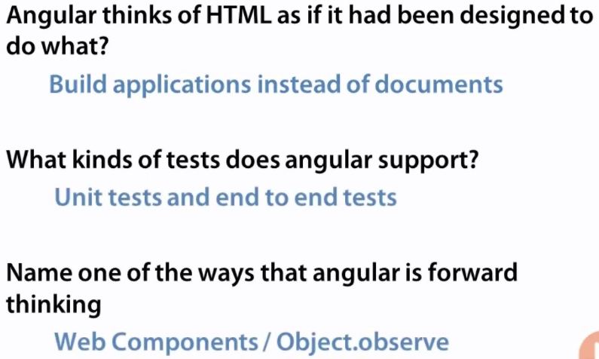

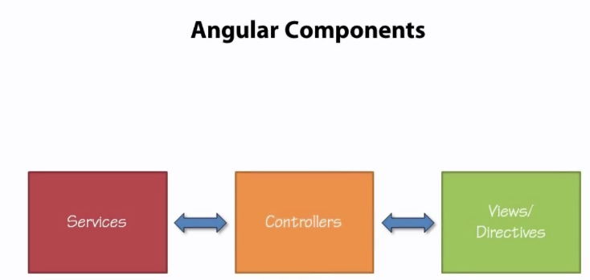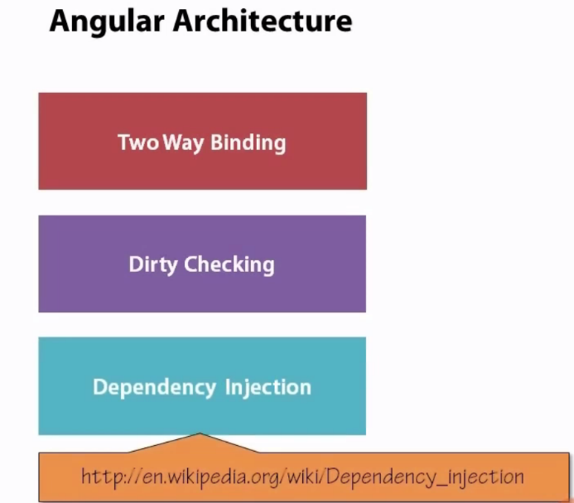

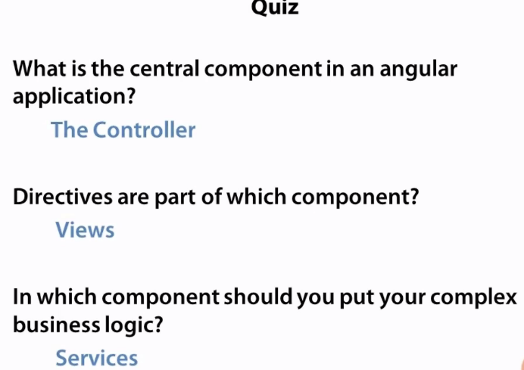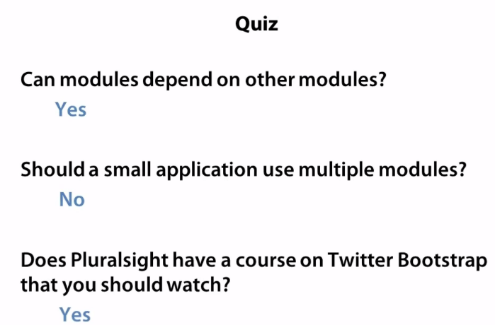

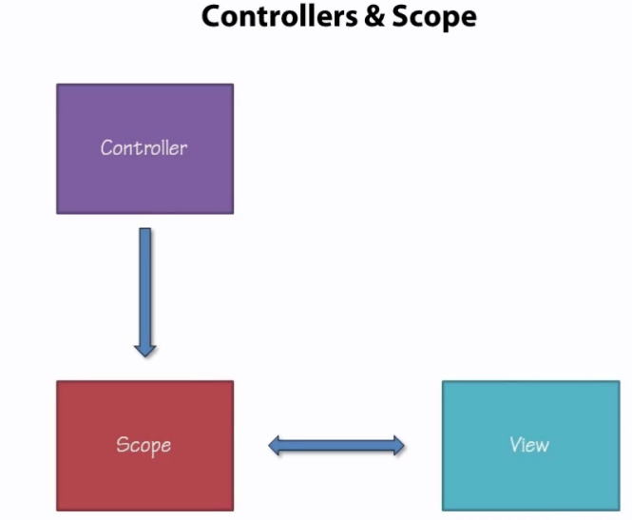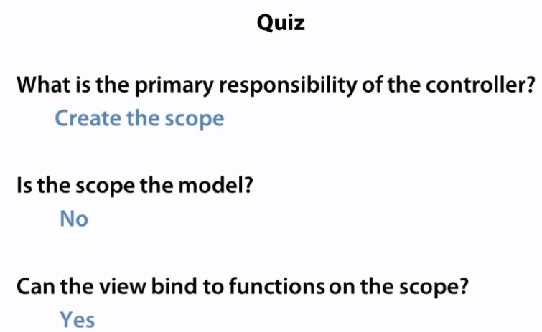

Scope is not a model, if we can change in model, it means scope’s function or variable.

Scope contains the model.

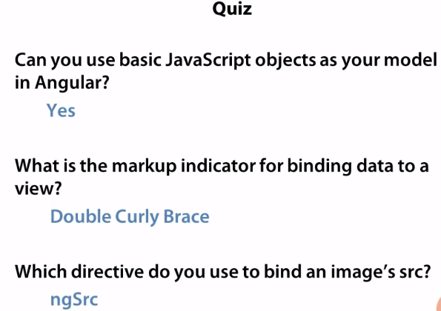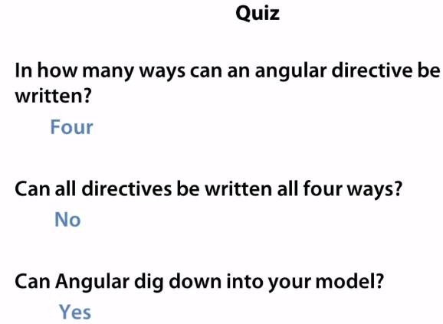

Note : In four ways angular directive can be written

1. Tag
2. Attributes
3. Class
4. As an html comments

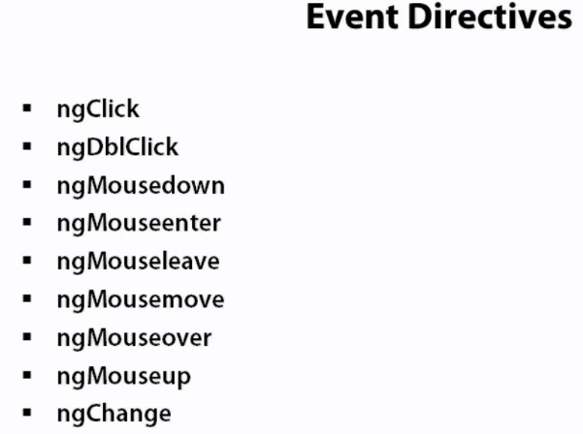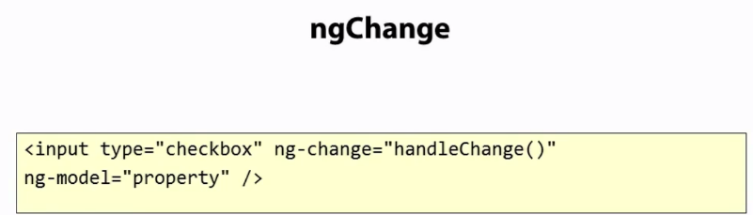

ngChange directive needs to have ng-model directive to get the value of ngChange event from view.

NG-BIND

* {{event.name}} this the way we do bind the data from model to view
* But we can do by ng-bind =”event.name”

NG-BIND-TEMPLLATE



We can do multiple data bind to particular attribute. Ex. Here name and date are going to display in page together.

NG-BIND-HTML





We can have html in the variable and assign to ng-bind-html that will render in page and color could not be there in page, because sanitize remove if anything is dangerous.

Sanitize is angular dependency which needs to ass in too module creation time.

NG-BIND-HTML-UNSAFE

* This is depreciated from angular.

NG-HIDE/NG-SHOW

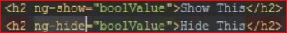

boolValue is scope’s model

NG-CLOAK

<body Ng-cloak>

Below code needs to add into CSS for getting activated this directive.

Special CSS rule. This is documented in angular documentation.



NG-STYLE

We can create model variable for scope and put some style and the scope variable directly can assign to ng-sytle = “abcStyle”, that style will be render on page.

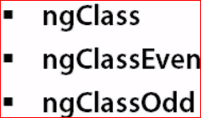

We can create a scope variable ‘scope.myClass : blue’, and write css for blue class and myclass will be assign to ngClass. Even and odd can be apply in ng-repeat loop for rendering even and odd element.

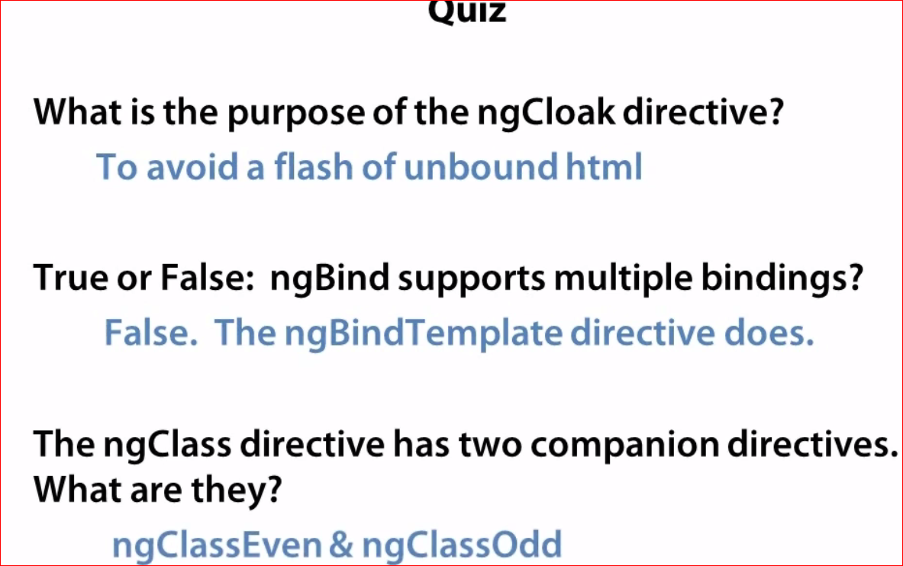

|  |  |
| --- | --- |
|  | Ng-desabled = “buttondesabled”  And in scope  $scope.buttondesbaled = true.  Button will disabled, these all other directives are working in same ways. |

|  |  |
| --- | --- |
|  | ngSubmit will invoke when form will submitted.  ngForm – its allow the nest form to each other.  ngNon-Bindable : this is illustrate that if {{1+2}} wanted to show in page you can use this directive.  Without this page will display result of its addition. Like 3 |

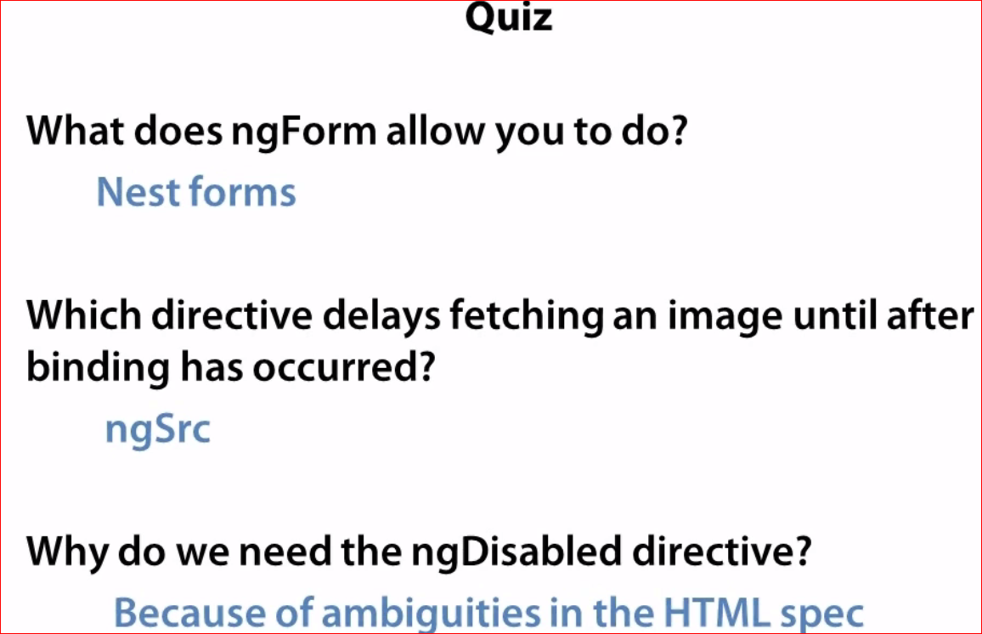

ngDesabled is disabling the control in all the browsers , if we do by CSS or java script, some browser don’t work as expected.

Angular IE restrictions:

1. Polyfill JSON.stringify
2. No ng tags

IE custom tag restrictions

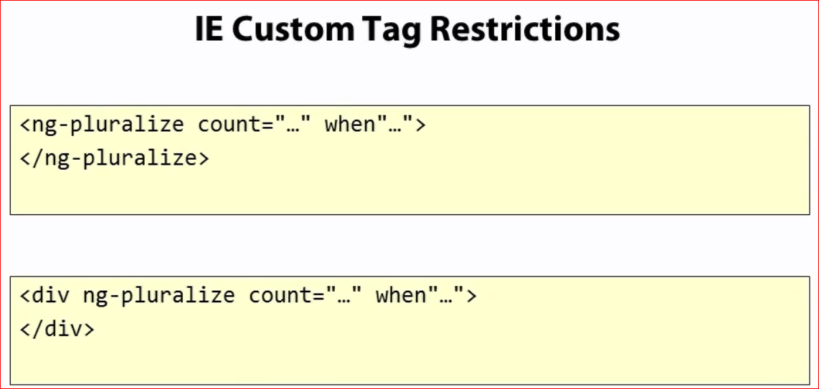

As above example ng-pluralize is tag and that will not work in IE so we can create directive by class or attributes form.

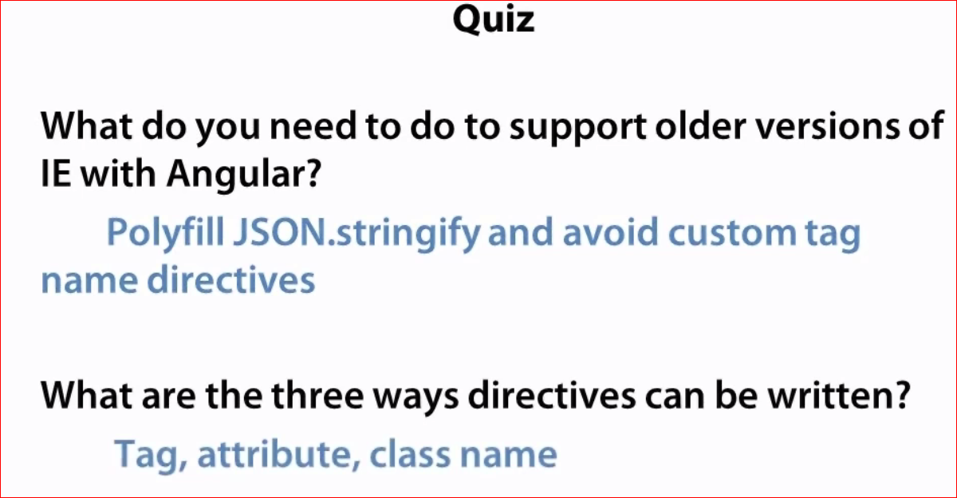

Filters

Filters can do following three things

1. Formatting
2. Shorting data set
3. Filtering data set

Ex. {{event.name | uppercase}}

{{1.333333 | number : 2}} = 1.33

{{1 | number : 2}} = 1.00

Orderby : shortOder

ngModel

it works in three ways

1. Select
2. Inputbox
3. textArea

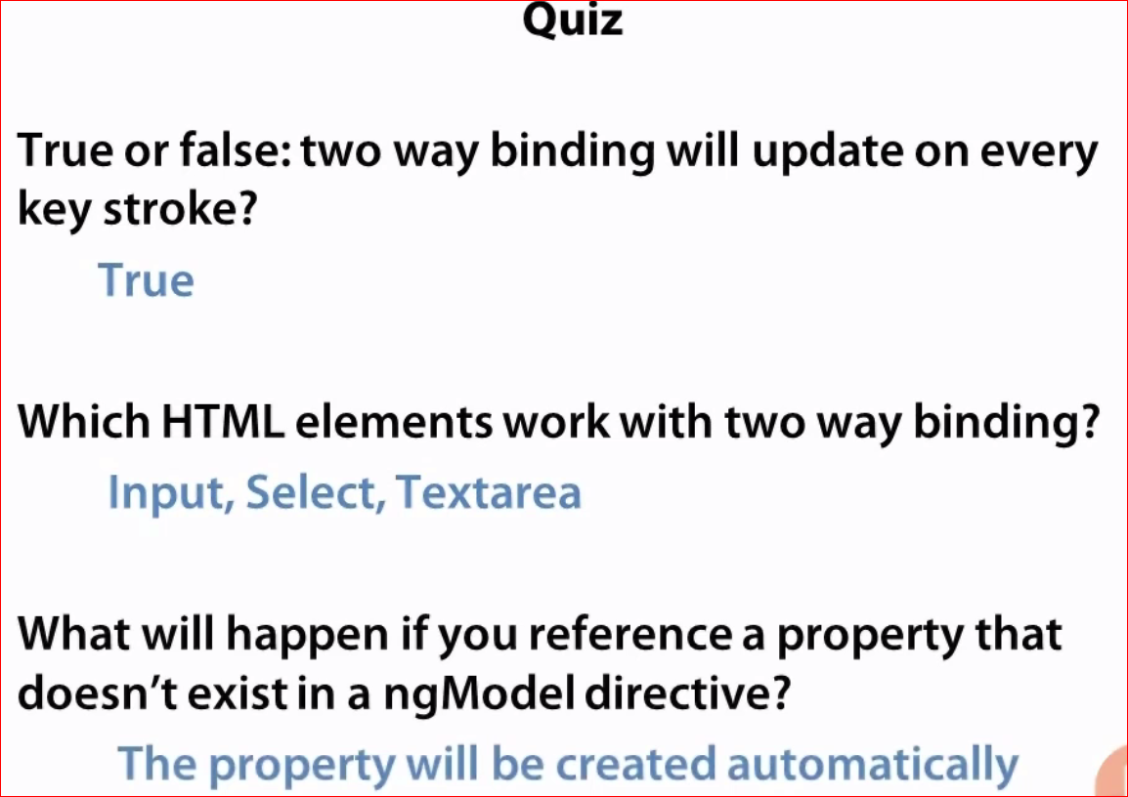

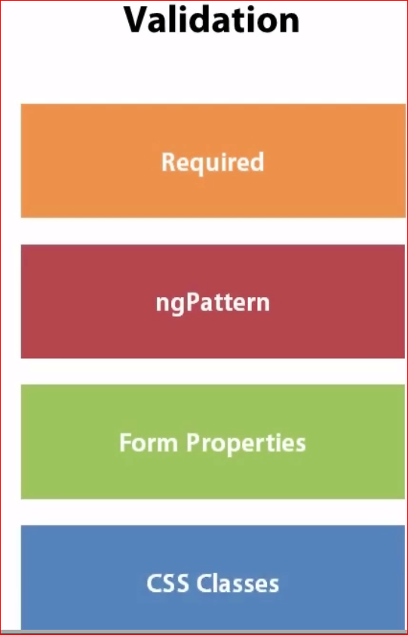

1. Required : just write “required” attribute in div or on element, that will make necessary to write in text field then only user can continue anything.
2. ngPattern : that is regex expression , text box will needed that to proceed continue to submit form or any action.
3. Form properties : ng-invalid, ng-dirty , will make validation more accurate and visible



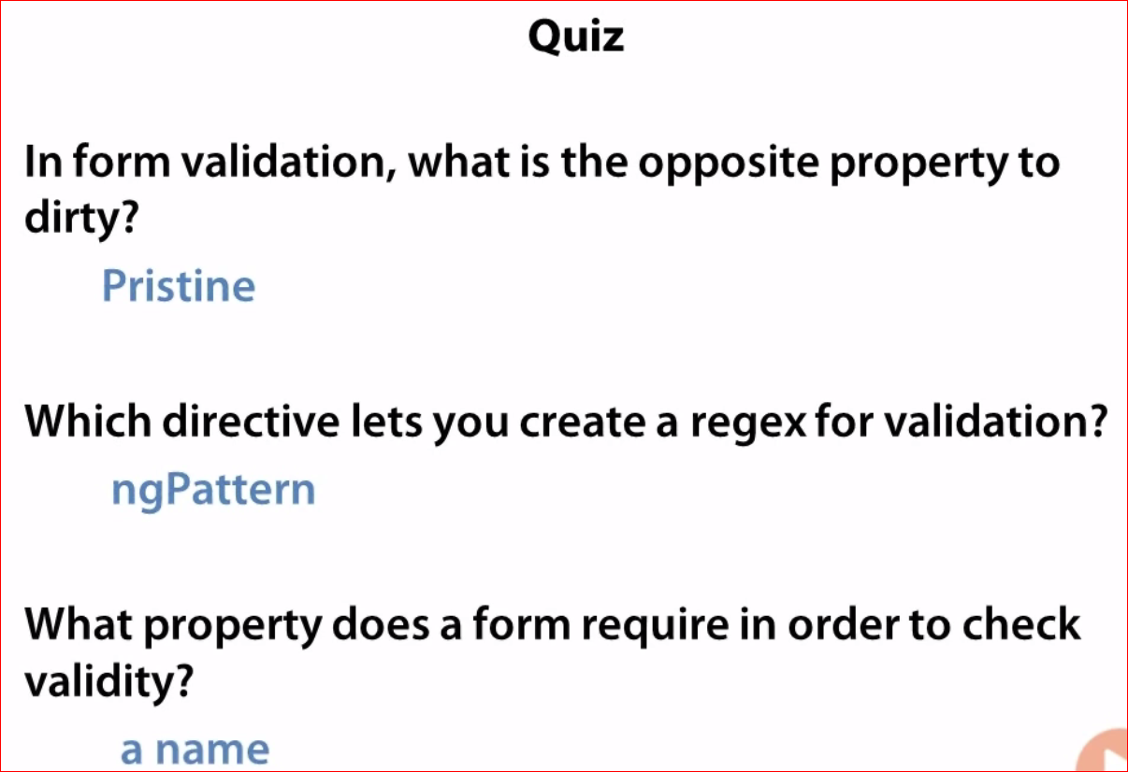 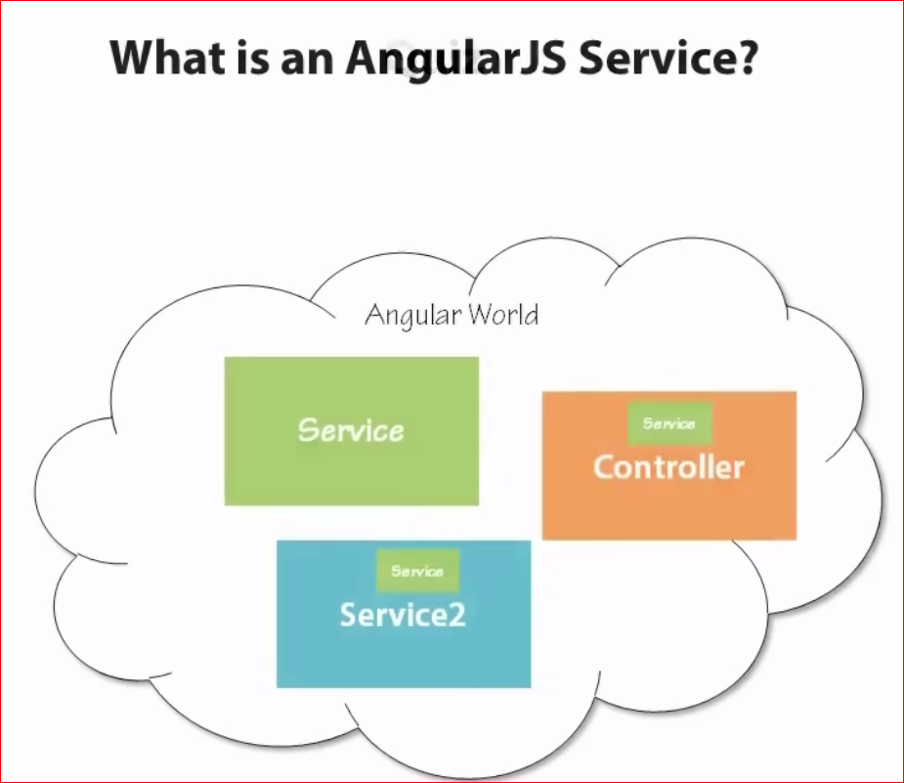

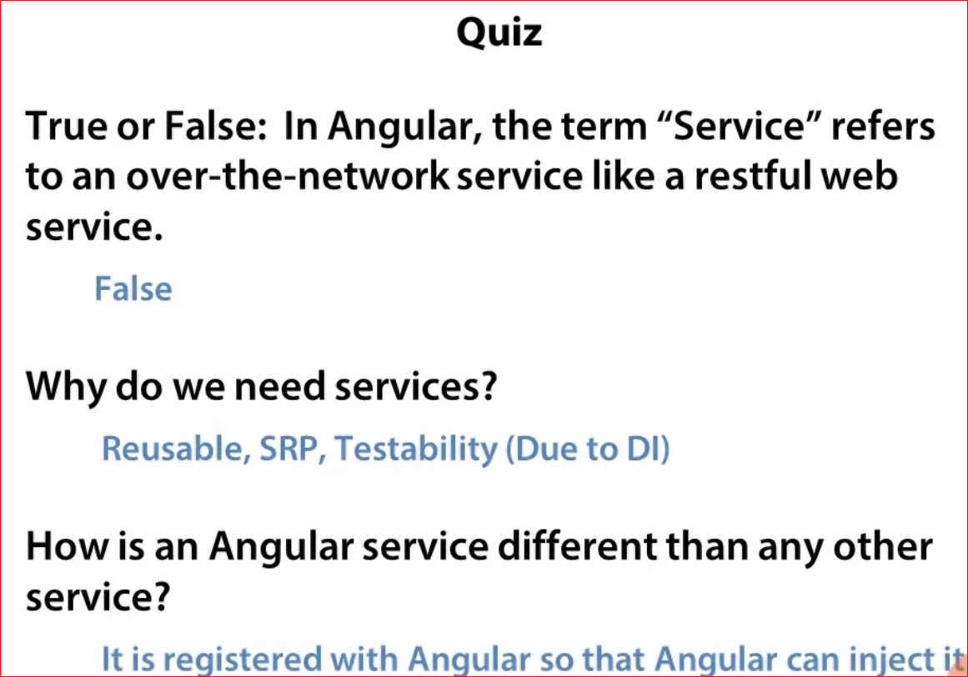

SRP : single responsibility principal.

DI : dependency injection

**Services**

**Custom build services**

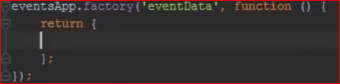

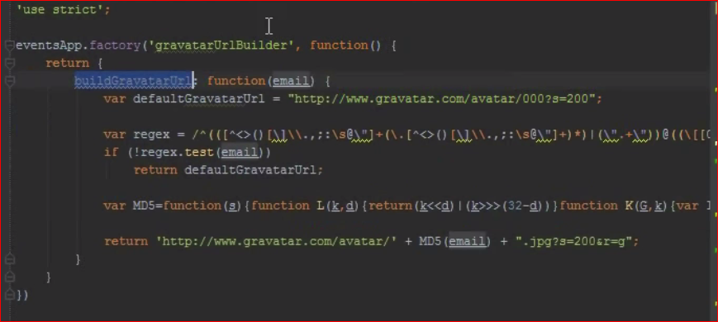

Angular build in services

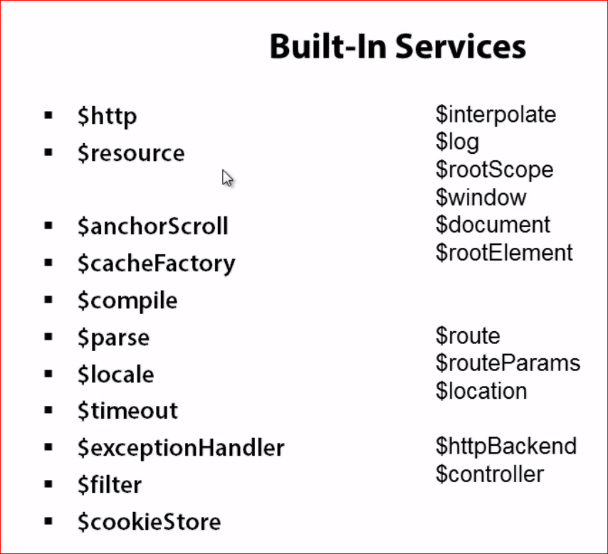

1. Httpd can be use for non restfull services implimention in angular.
2. Resource is useful for rest full services.

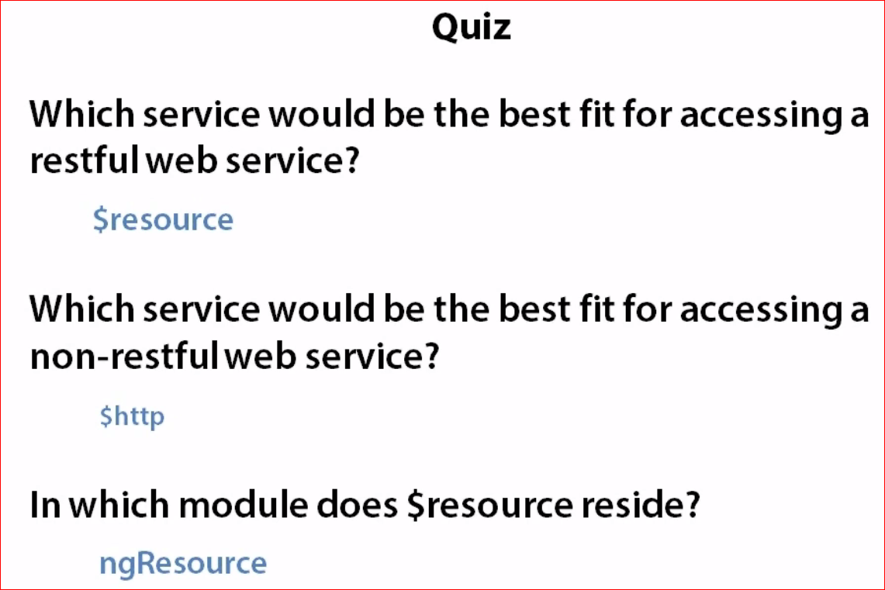

Caching in angular

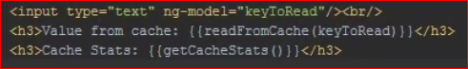

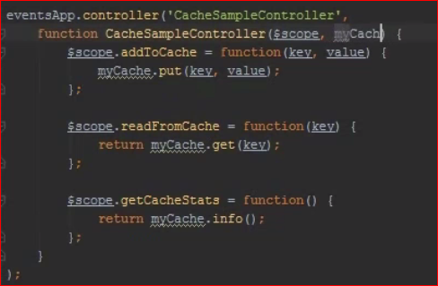

Communication between One controllers to another

HTML

<div ng-controller="ControllerZero">

<input ng-model="message" >

<button ng-click="handleClick(message);">BROADCAST</button>

</div>

<div ng-controller="ControllerOne">

<input ng-model="message" >

</div>

<div ng-controller="ControllerTwo">

<input ng-model="message" >

</div>

<my-component ng-model="message"></my-component>

Java script

var myModule = angular.module('myModule', []);

myModule.factory('mySharedService', function($rootScope) {

var sharedService = {};

sharedService.message = '';

sharedService.prepForBroadcast = function(msg) {

this.message = msg;

this.broadcastItem();

};

sharedService.broadcastItem = function() {

$rootScope.$broadcast('handleBroadcast');

};

return sharedService;

});

myModule.directive('myComponent', function(mySharedService) {

return {

restrict: 'E',

controller: function($scope, $attrs, mySharedService) {

$scope.$on('handleBroadcast', function() {

$scope.message = 'Directive: ' + mySharedService.message;

});

},

replace: true,

template: '<input>'

};

});

function ControllerZero($scope, sharedService) {

$scope.handleClick = function(msg) {

sharedService.prepForBroadcast(msg);

};

$scope.$on('handleBroadcast', function() {

$scope.message = sharedService.message;

});

}

function ControllerOne($scope, sharedService) {

$scope.$on('handleBroadcast', function() {

$scope.message = 'ONE: ' + sharedService.message;

});

}

function ControllerTwo($scope, sharedService) {

$scope.$on('handleBroadcast', function() {

$scope.message = 'TWO: ' + sharedService.message;

});

}

ControllerZero.$inject = ['$scope', 'mySharedService'];

ControllerOne.$inject = ['$scope', 'mySharedService'];

ControllerTwo.$inject = ['$scope', 'mySharedService'];

Compile service

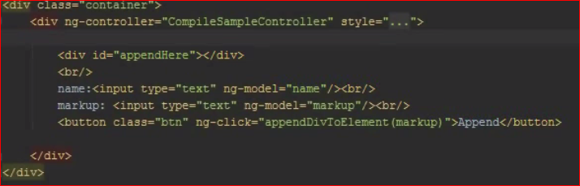

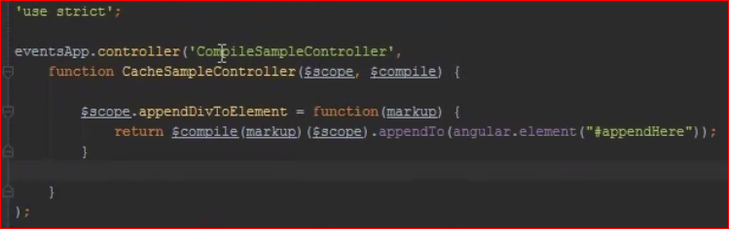

Parse services

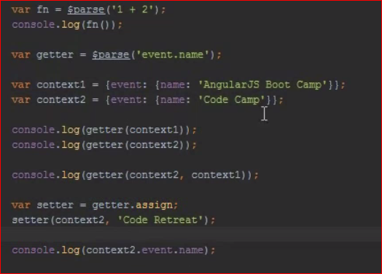

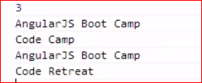

Locale

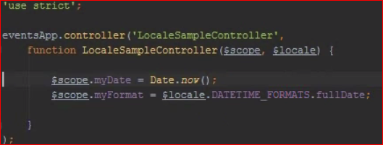 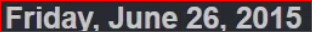

.shortDate - 06/26/2015

Note : You can add any country localization that needed to have .js file for particular local.

Timeout service

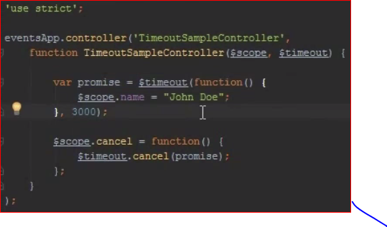

Note if you setimeout of javascript , that timeout will work but anular will not be aware about that. So use only timeout service in angular code.

And this returns the object, with that you can cancel at any time timeout recurring.

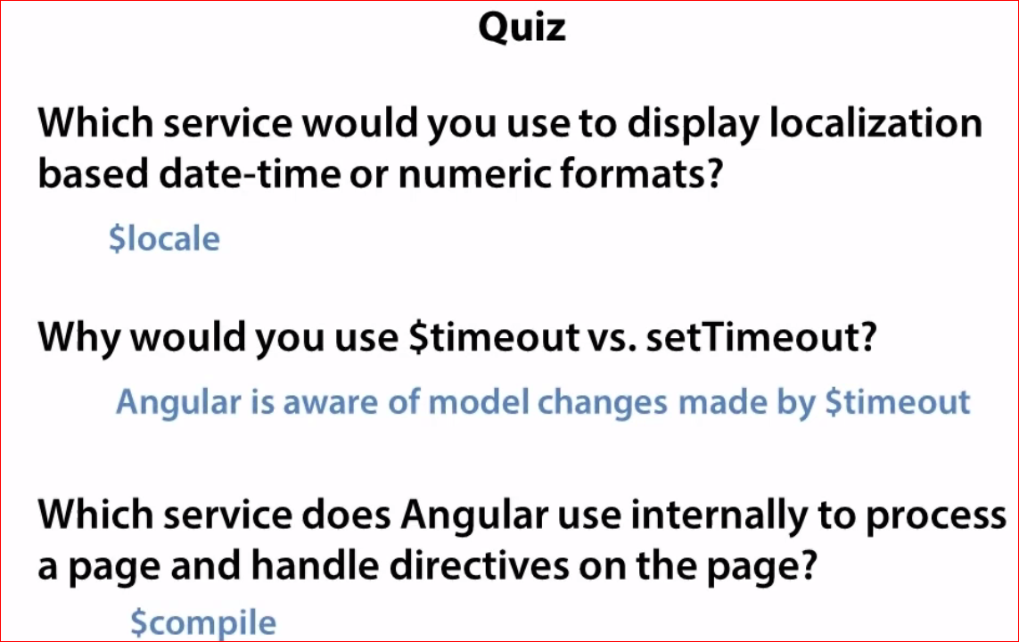

CockieStore

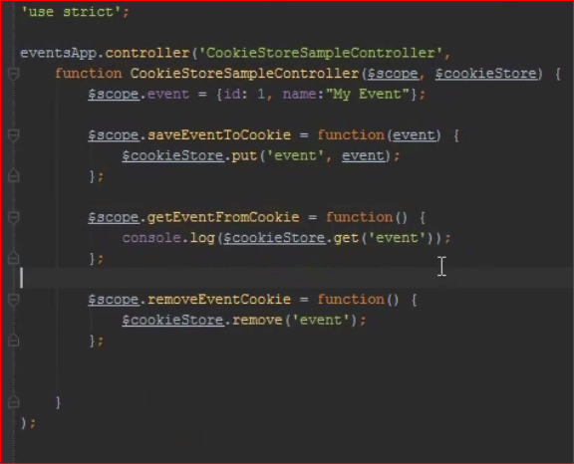

Angular don’t care about expiration dates of cokies, so if you to have coikies exipration dates, have 3rd party library to get that.

Below highlighted directives are genrallly not used in application level.

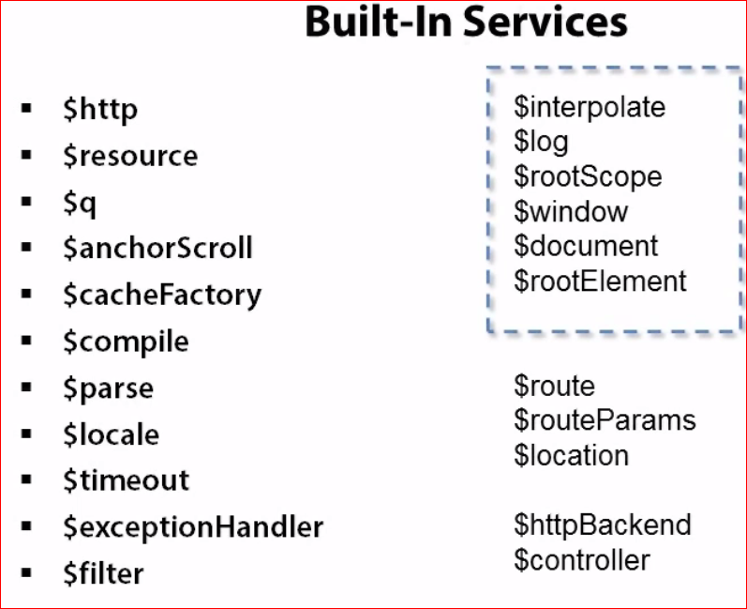

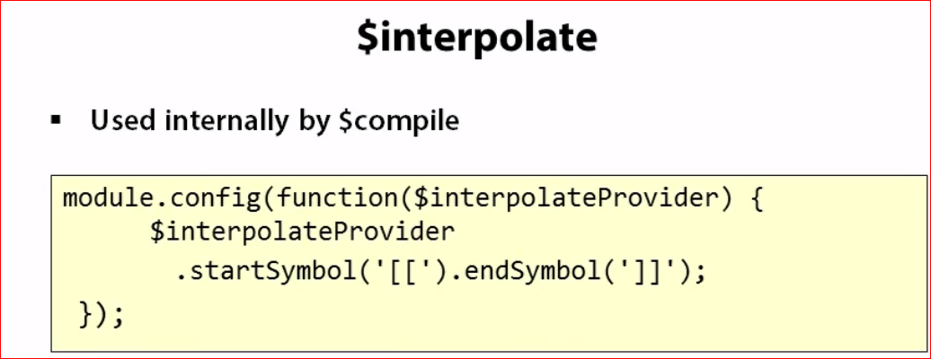

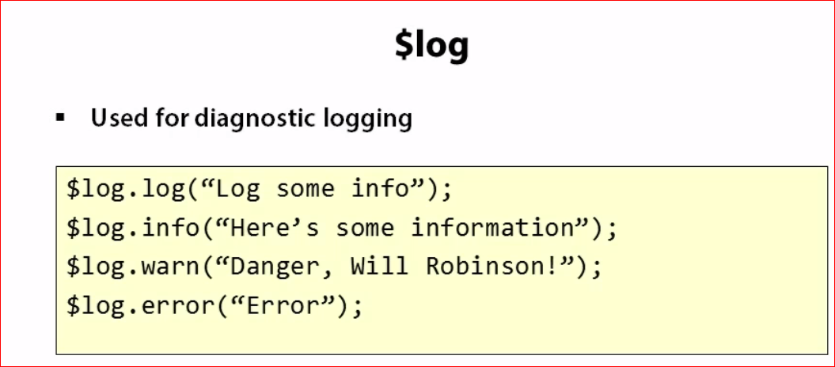

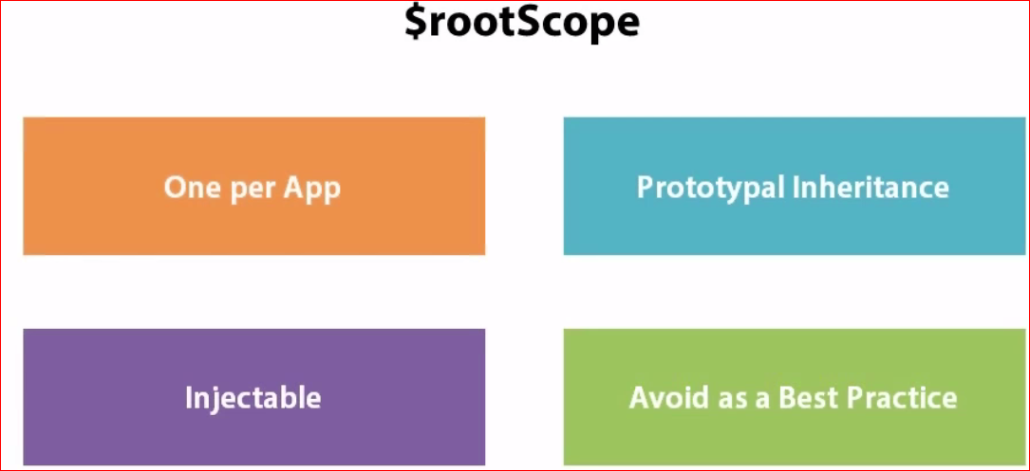

Don’t manipulate DOM directly in angualr and instead you can do hough data bindings.

Below servivces can provide javascript as metioned name.

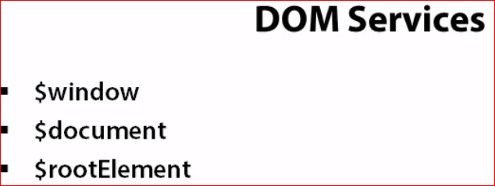

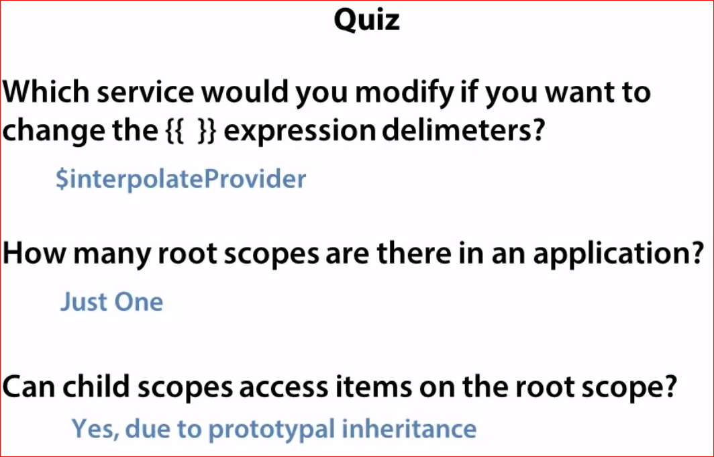

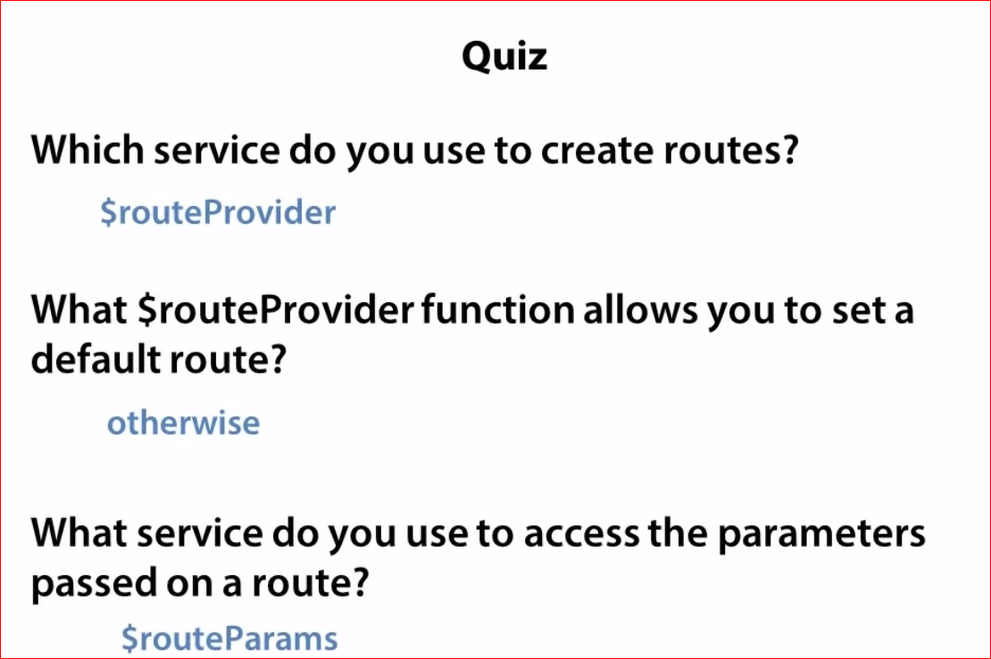

1. RouteParam service is providing the url based parameter to use in controller.
2. $route service can get the valuses from route functions and can accesble in controller

Ex.

$routeProvider.when(‘/event/:id’,{

Foo : “bar”

TemplateUrl : “templates/index.html”,

Controllers : “eventController”

})

In the controller

Use $route sevice and use below code

$route.current.foo -> bar

1. Route service can redload the page which just chnages by user only, rest page will not reload , this is awesome quality it has.

Route.reload(); assign to any scope.function and put into ng-click directive

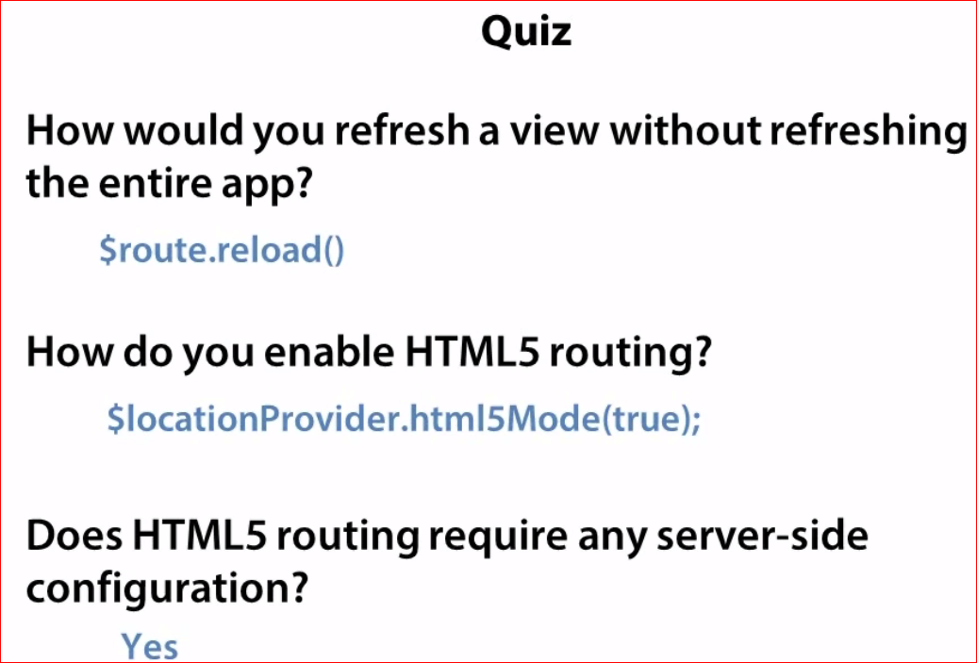

$resources comes with promise

If due to ajax delay call in page, page can be partially render and looks bad , you can do below;

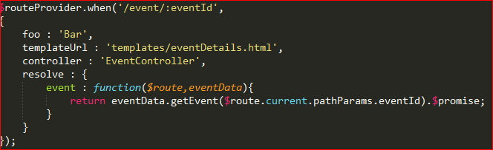

Resolve member of routeprovider, that’s makes manually make promise to get the data to angular.

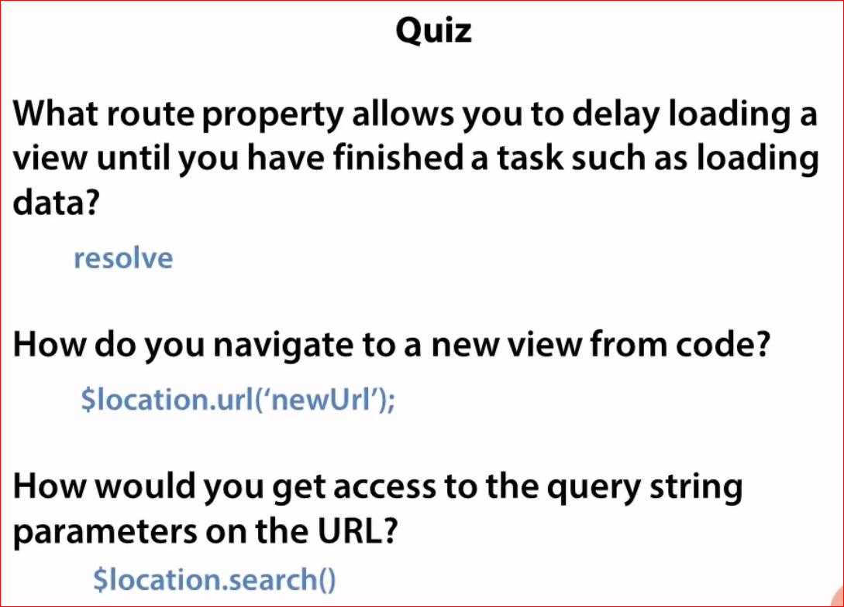

**Directives**

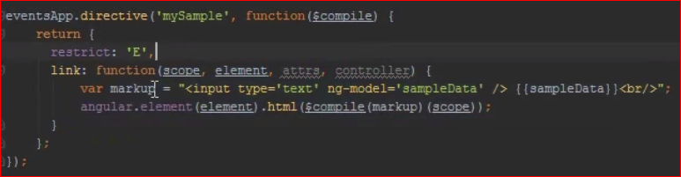

With a template keyword we can do the same behaviear.

Restrict can C or E , class oe eliment .

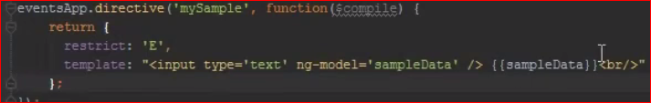

If you want create thumbenal directive just write here thumbnal html or url or thubnal html, that it.

If above diretive if you use in multple place in page they will work In sameway, so if you type in one text box, it will display in all,

So do below , scope property will make then separate.

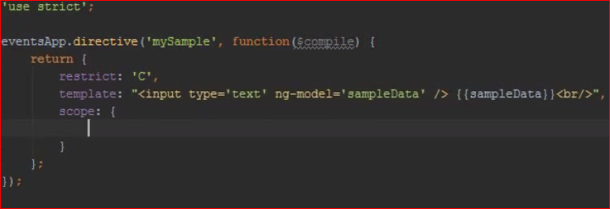

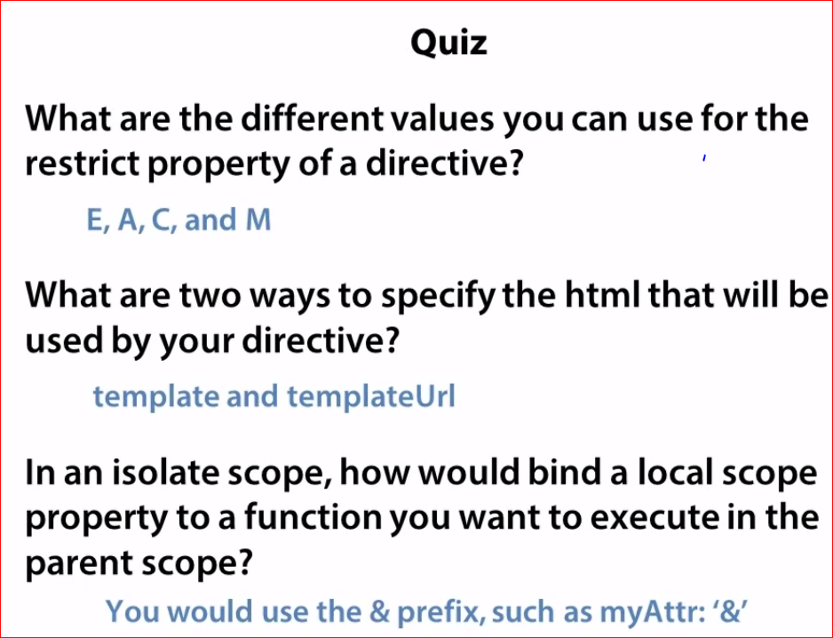

E – Eliment

1. Attributes

C – class

M – comments

Controller in directives

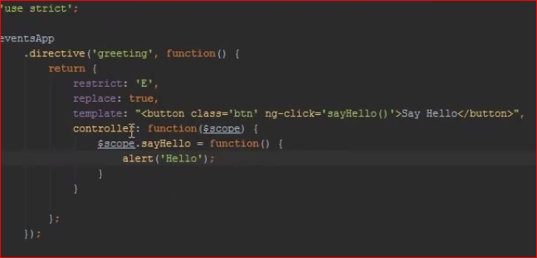

We can assing controller name into controller property for directive

As below

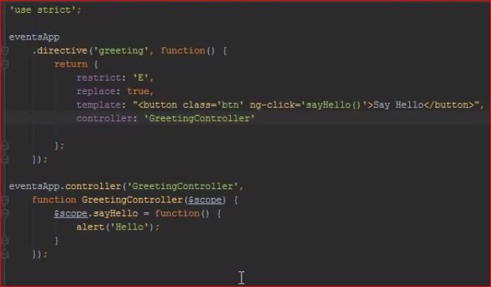

If outside of direvivce and used in directive tag



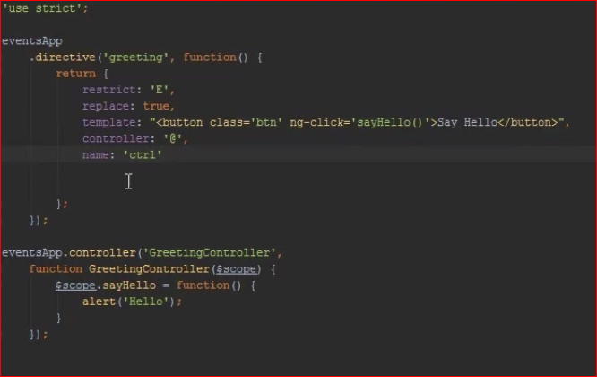

**Multimple Directives communication to each other and controller also can be accessble by this way, see in below example**

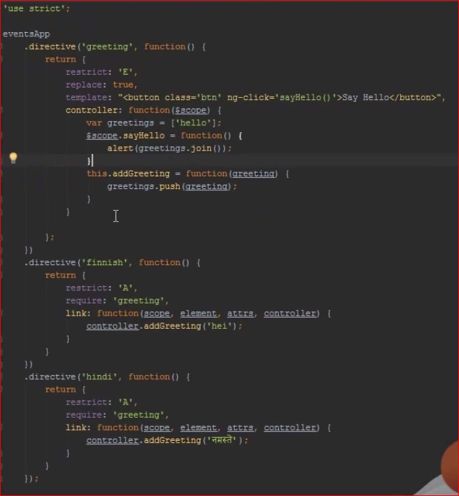

**On above eaxmple , if you can set periority [periority :1 or 2 in directives], it will make a order.**

